Info On Demand Selection Control Function – CGEA 1.3 – S550 Specific

Functional Description

This STSS describes the selection of the Info On Demand display. This STSS is applicable when the cluster has an Info On Demand (IOD) Display Zone. The IOD Menu consists of a list of IOD items that can be selected by the vehicle occupant. Once an IOD Menu item is selected, the IOD item selected will be displayed in the proper IOD display zone.

The IOD Menu can vary from program to program and a program specific IOD Menu List will be specified in a program specific IPC Menu Structure file. Each IOD Item will have an associated graphic layout specified in a program specific Wallpaper file. A “No Info Display” entry will be the top item in every menu list and will be the battery connect default. The selected IOD Menu will be retained during a Key Cycle.

Interfaces

Interface Context Diagram (I/O Block Diagram)
- Info On Demand Selection Control Function Context Diagram
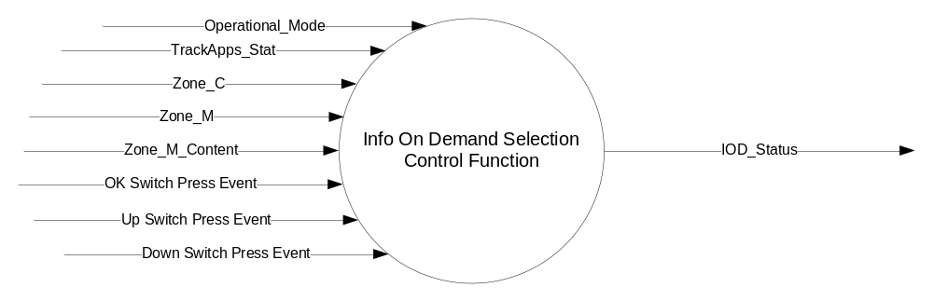

Inputs

- INTERNAL:
- Operational_Mode
- OK Switch Press Event
- Up Switch Press Event
- Down Switch Press Event
- Zone_C
- Zone_M
- Zone_M_Content
- TrackApps_Stat

Outputs
- IOD_Status, variable to identify the currently selected Info On Demand Display

Function/Performance

Operational Modes

Mode | Differentiating Vehicle Conditions
Sleep Mode | Info On Demand Selection Control Function Disabled
Limiting Mode | Info On Demand Selection Control Function Disabled
Normal Mode | Info On Demand Selection Control Function Enabled / Disabled
Crank Mode | Info On Demand Selection Control Function Enabled / Disabled

Voltage Levels

Refer to the Cluster Features table located in the Operational Modes and Voltage Range Strategies Section in this SPSS.

Human-Machine Interface

Visual

Indicator Graphics / Display Format
Refer to “<Program> Cluster Menu Structure.xls”.
This is an example of a layout from a program specific Menu Structure file.

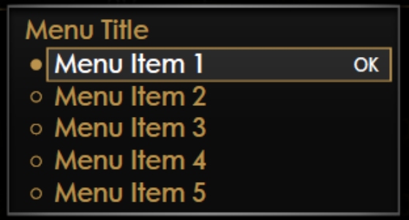

Row  `  `  `  `  `  `  `  `  `  `  `  `  `  `  `  `  `  `  `  `  `  `  `  `  `  `  `  ` | Text
Menu Title | Settings – Information
Menu Item 1 | None
Menu Item 2 | Trip 1
Menu Item 3 | Trip 2
Menu Item 4 | Fuel Economy Histogram
Menu Item 5 | TPMS Status
Menu Item 6 | Temperatures
Menu Item 7 | Boost and Air/Fuel Ratio
Menu Item 8 | Oil Press. and Voltage
Menu Item 9 | Accelerometer
Menu Title | Pony – System Status
Menu Item 1 | Status Screen
Menu Title | Pony – MyGauges
Menu Item 1 | MyGauges

Indicator Color Coordinates

Reference Ford HMI or Studio Wallpaper files for the specific program.

Indicator Characteristics

Reference Ford HMI or Studio Wallpaper files for the specific program.

Audio

None

Switch Control Logic

Consumer access to the Info On Demand Selection Control Function shall be as specified in the message center basic functionality display as specified in Message Center STSS. The Switch logic while the IOD Menu is the active display is in this STSS.

System Accuracy

Within a 100msec of receiving a message that results in a change of state the cluster will update the display to the proper status.

Operation: Performance and Functional

Subsystem Algorithm Flowchart / State Diagram
- Info On Demand Selection Control Function Flowchart
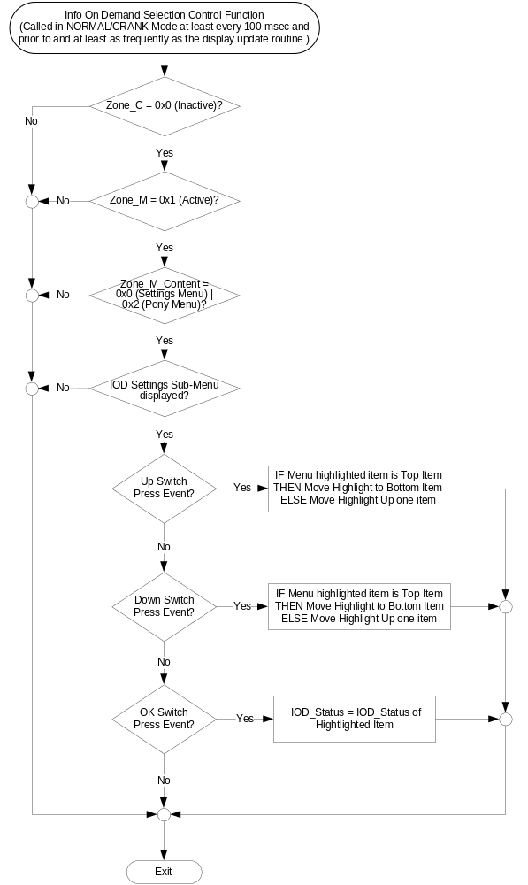
- Scrolling Info On Demand Control Function Flowchart
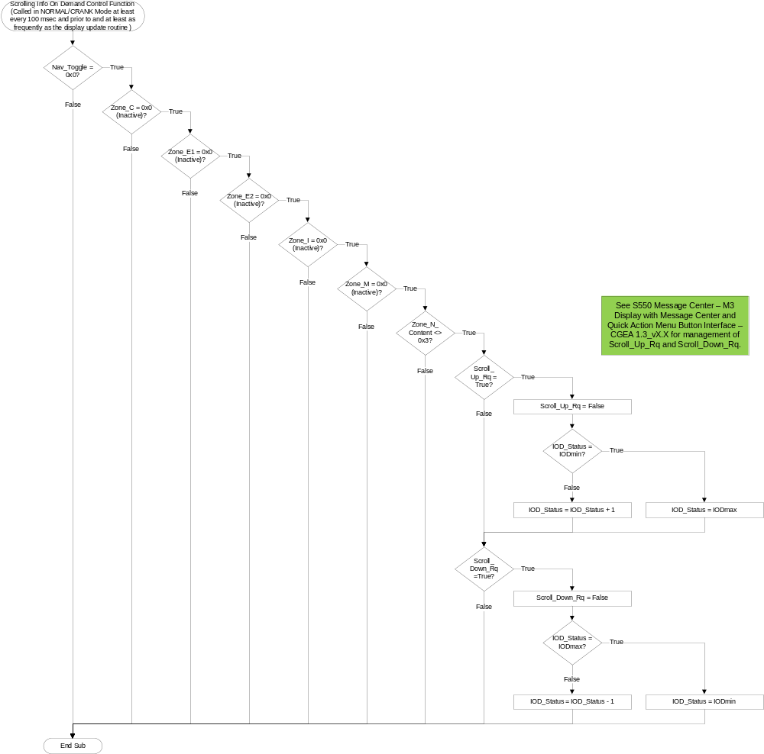
- IODmin and IODmax
 | TrackApps_Stat = 0 | TrackApps_Stat <> 0
IODmin | 0x0 | 0xB
IODmax | 0xA | 0xF
Up/Down press will add/subtract one from IOD_Status with wraparound at IODmin/IODmax. IOD scrolling is currently not available in TrackApps (i.e. TrackApps_Stat <> 0)

- Info On Demand based on TrackApps_Stat
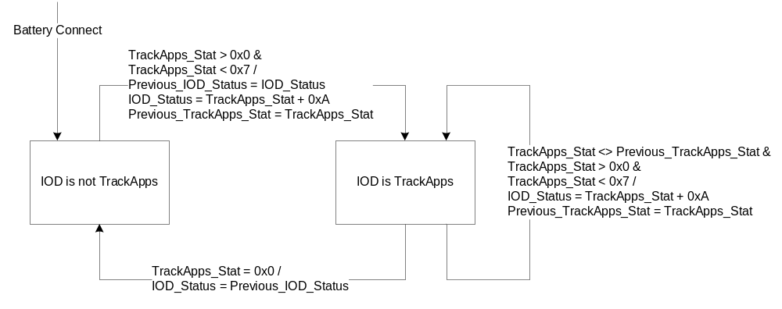

Operation Description (supports algorithm flowchart /state diagram)

- IOD_Status
IOD_Status | Program Specific Example |  | Comment
IOD_Status | IOD Screen | IOD_Enabled | Comment
0x0 | No Info Display | 0x1 | IoD area set to empty
0x1 | Trip 1 | 0x1 | previous IoD content replaced with trip 1
0x2 | Trip 2 | 0x1 | previous IoD content replaced with trip 2
0x3 | Fuel Economy Histogram | Fuel_Histogram_Dsply_Cfg | previous IoD content replaced with fuel economy
0x4 | TPMS Status | TPMS_Cfg | previous IoD content replaced with TPMS
0x5 | Temperatures | Oil_Temp_display_Cfg Cylinder_Head_Temp_display _Cfg Inlet_Air_Temp_display_Cfg | previous IoD content replaced with gauges: oil temperature, cylinder head temperature, inlet air temperature
0x6 | Boost and Air/Fuel Ratio | Boost_Vac_Cfg  Vac_Gauge_Display_Cfg  Air_to_Fuel_Ratio_display_Cfg | previous IoD content replaced with gauges: boost/vacuum, air/fuel ratio
0x7 | Oil Press. and Voltage | Battery_Voltage_display_Cfg | previous IoD content replaced with gauges: oil pressure and voltage
0x8 | Accelerometer | Accelerometer_Cfg | previous IoD content replaced with accelerometer
0x9 | Status Screen | Status_Screen_Cfg | previous IoD content replaced with status screen
0xA | MyGauges | MyGauges_Cfg | previous IoD content replaced withselected gauges
0xB | TrackApps – Acceleration Timer | Acceleration_Timer_Cfg | Can only access through TrackApps menu. Not selectable in IoD menu.
0xC | TrackApps – Brake Performance | Brake_Performance_Cfg | Can only access through TrackApps menu. Not selectable in IoD menu.
0xD | TrackApps – Line Lock | Line_Lock_Cfg | Can only access through TrackApps menu. Not selectable in IoD menu.
0xE | TrackApps – Lap Timer | Lap_Timer_Cfg | Can only access through TrackApps menu. Not selectable in IoD menu.
0xF | TrackApps – Start Option | Countdown_Start_Cfg | Can only access through TrackApps menu. Not selectable in IoD menu.

- The above is an example on how to define the IOD_Enabled array. A program specific list of IOD Screens will be created. Each IOD Screen is assigned an IOD_Status value. “No Info Display” will always be assigned the IOD_Status value of 0x0 and an IOD Screen is not associated with it. The IOD_Enabled array is used to determine if the corresponding IOD Screen will be included in the IOD Menu list. If the value of IOD_Enabled is equal to 0x1, the corresponding IOD Screen is to be included in the IOD Menu List.
- Only IOD Screens whose corresponding IOD_Enabled value is 0x1 will be displayed in the IOD Menu List and thus they are the only ones that can be highlighted and selected as specified in the Info On Demand Selection Control Function Flowchart.
- When an IOD Menu item is selected as specified in the Info On Demand Selection Control Function Flowchart, the selected IOD Screen is displayed unless “No Info Display” was selected, in which case no IOD Screen is displayed. This is specified in the appropriate Message Center Display STSS.
- After choosing a TrackApps (except for the Performance Shift Indicator) from the menu, the menu closes and the first step of the TrackApps specific features is shown in the IoD area. When the TrackApps is exited, the IoD goes back to its original state.
- IoD area is transitions from Half Compass mode on first press and advances to next IoD on next message center toggle switch press. This is handled in the S550 Message Center – M3 Display with Message Center and Quick Action Menu Button Interface – CGEA 1.3_v3.0 or higher STSS.
- If IoD is displayed and Up button is pressed, then next (up the list of IoD) IoD is displayed in order on how it is IoD menu selection shown in "Display Setup". If at Top of the list and Up was pressed then the next IoD that will be shown in the IoD that is at the bottom of the list.
- If IoD is displayed and Down button is pressed, then next (down the list of IoD) IoD is displayed in order on how it is IoD menu selection shown in "Display Setup". If at bottom of the list and Down was pressed then the next IoD that will be shown in the IoD that is at the top of the list.
- No movement from one IoD to another IoD via message center Toggle switch when in Trac Apps.

Function Safety Classification (EMC)

Class B

Memory Storage

Parameter Name | Description | Value at  Battery Connect | Value at Module Wake-up
Down Switch Press Event | Event that is indicated as per the switch interface for the Message Center *. | See 2 below | See 2 below
IOD_Enabled [ x ] | State Indicator Array to identify if the associated IOD Menu Item is present in an individual vehicle. | Program Specific | Program Specific
IOD_Status | State Indicator to identify which Info On Demand Display should be currently Active  0x0 (No Info Display)  0x1 (Trip 1)  0x2 (Trip 2)  0x3 (Fuel Economy Histogram)  0x4 (TPMS Status)  0x5 (Temperatures)  0x6 (Boost and Air/Fuel Ratio)  0x7 (Oil Press. and Voltage)  0x8 (Accelerometer)  0x9 (Status Screen)  0xA (MyGauges)  0xB (TrackApps – Acceleration Timer)  0xC (TrackApps – Brake Performance)  0xD (TrackApps – Line Lock)  0xE (TrackApps – Lap Timer)  0xF (TrackApps – Start Option) | 0x0 (No Info Display) | Do Not Init
OK Switch Press Event | Event that is indicated as per the switch interface for the Message Center *. | See 2 below | See 2 below
Operational_Mode | 4 state indicator for cluster operational mode | Limited | Limited, Normal or Crank
Previous_IOD_Status | State Indicator to identify which Info On Demand Display is Active prior to entering a TrackApps IoD.  0x0 (No Info Display)  0x1 (Trip 1)  0x2 (Trip 2)  0x3 (Fuel Economy Histogram)  0x4 (TPMS Status)  0x5 (Temperatures)  0x6 (Boost and Air/Fuel Ratio)  0x7 (Oil Press. and Voltage)  0x8 (Accelerometer)  0x9 (Status Screen)  0xA (MyGauges)  0xB (TrackApps – Acceleration Timer)  0xC (TrackApps – Brake Performance)  0xD (TrackApps – Line Lock)  0xE (TrackApps – Lap Timer)  0xF (TrackApps – Start Option) | 0x0 (No Info Display) | Do Not Init
Previous_TrackApps_Stat | State Indicator to identify the previous state of TrackApps. Used to detect a change in the Active TrackApps.  0x0 (Inactive)  0x1 (TrackApps – Acceleration Timer)  0x2 (TrackApps – Brake Performance)  0x3 (TrackApps – Line Lock)  0x4 (TrackApps – Lap Timer)  0x5 (TrackApps – Start Option)  0x6 (Reserved)  0x7 (TrackApps – Return to QAM) | 0x0 (Inactive) | Do Not Init
TrackApps_Stat | State Indicator to identify the state of TrackApps.  0x0 (Inactive)  0x1 (TrackApps – Acceleration Timer)  0x2 (TrackApps – Brake Performance)  0x3 (TrackApps – Line Lock)  0x4 (TrackApps – Lap Timer)  0x5 (TrackApps – Start Option)  0x6 (Reserved)  0x7 (TrackApps – Return to QAM) | 0x0 (Inactive) | Do Not Init
Up Switch Press Event | Event that is indicated as per the switch interface for the Message Center *. | See 2 below | See 2 below
Zone_C | State indicator to identify if Zone C is currently being displayed (Active = 0x1). | See 1 below | See 1 below
Zone_M | State indicator to identify if Zone M is currently being displayed (Active = 0x1). | See 1 below | See 1 below
Zone_M_Content | State Indicator to identify which display is currently active in Zone M. | See 1 below | See 1 below
1 Refer to the appropriate Message Center Display STSS.
2 Refer to appropriate Message Center Switch Interface STSS.

Reconfigurable Telltale

Not Applicable

Prove Out

Not applicable

Message Center Msg

Refer to text as defined in the Text Translation file.

Error Handling

No missing message strategy defined for these input signals.

Diagnostics

Self Test

None

Engineering Test Mode

None

Part II Performance

Supported Diagnostic Trouble Codes (DTCs) - None

DID DExx - None

Reference Specification
- Appropriate Message Center Display STSS
- Appropriate Message Center Switch STSS
- Appropriate Program Specific Text Translation File
- Appropriate Program Specific IPC Menu Structure File

Revision History
SPSS Module Revision History

Revision Level | Name | Change Description | Date
1.0 | T. Cwik | Initial release | 8/25/2014
2.0 | T. Cwik | Updated to agree with new program direction resulting from HMI survey results of 22-26 Sept 2014 in Arizona.  - Added the word “Control” to the name of the feature throughout the document.  - Section 1.2.1 – Figure 1 – Added Zone_C1, Zone_C1_Focus  - Section 1.2.2 – Added Zone_C1, Zone_C1_Focus  - Section 1.3.5.1 – Figure 2 – Changed the first Decision Diamond and added two more Decision Diamonds.  - Section 1.3.5.4 – Added Zone_C1, Zone_C1_Focus | 10/29/2014
S550 – 1.0 | J. Gregoire | Initial release.  This STSS is based Info On Demand Selection Control Function - CGEA1.3_v2.0, but has been heavily updated to support the special functionality on S550. | 2/19/2016
S550 – 2.0 | J. Gregoire | Changes are highlighted in Orange.  Add Scrolling IoD. (Approved in 9/15/2016 DI CC).  Page 4 Figure 3 – New flowchart for Scrolling IOD logic.  Page 4 Table 1.0 – New table for IODmin and IODmax.  Page 6 Section 1.3.5.2 – Add Operation Description for Scrolling IOD. | 10/7/2017

